Font:
Roboto+Condensed
https://fonts.google.com/selection?query=robo&selection.family=Roboto+Condensed
Lato
https://fonts.google.com/selection?selection.family=Lato|Roboto+Condensed&query=lato
Fredoka One
https://fonts.google.com/selection?query=Fredoka&selection.family=Fredoka+One

Asset Loan Form Section
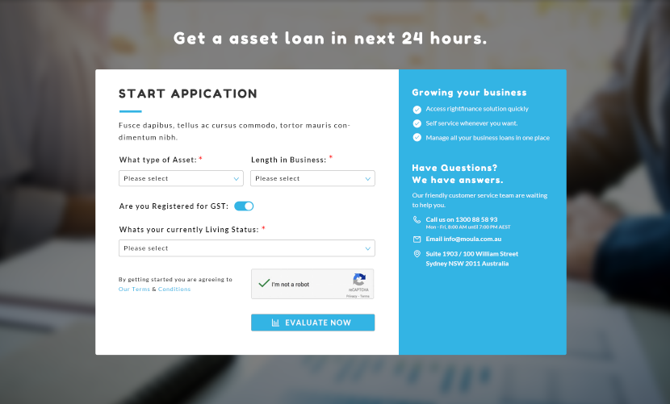
Big Title “Get a asset loan in next 24 hours” Font size: 40px; Font family: Fredoka One; Color:white

Form: border radius 3px;
Button and input: border radius 3px;

Form:
Left Side:
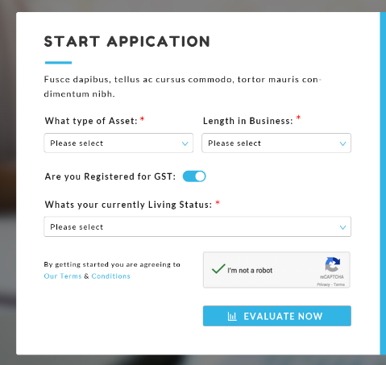
Background color: white

Big Title “Start Application” Color: # 373737 Big Title font size: 30px Big Title Font family: Fredoka One

<HR> Color:# 32b5e5

“*” Color: red

Content Color: #010101 Content font size: 18px Content Font family: Lato
Content Font weight: normal

Title Color: #1c1c1c Title font size: 30px Title Font family: Lato
Title Font weight: Bold

INPUT background: white border: #b5b5b5 font-size:16px

Button Background:# 32b5e5 Color:white Font size: 18px Font-family: Lato Font weight:bold

Term and condition text:
Font size: 14px Font-family: Lato Font weight:normal

Right Side:
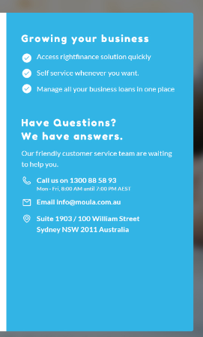

Background color: #32b5e5

Font Color:white

Title Color: white Content font size: 22px Title Font family: Fredoka One Font weight:bold

Content: Color: white Content font size: 16px Content Font family: Lato Font weight:normal

Small Content Color: #f1f1f1 font size: 12px Font weight:normal

